# Section A:

**TK 1143 Program Design 2020/2021 Polymorphism**

1. Based on the following code, can you identify either it is constructor overloaded or method overloaded? Justify your answer.

|  |  |
| --- | --- |
| 1  2  3  4  5  6  7  8  9  10 | public class Kira  {  public Kira(){  //-----> (1)  }  Public void Kira() {  //-----> (2)  }  } |

Answer:

Constructor Overloading.

This is because there is constructors having the same name with different parameter.

1. a) Understand the following code and predict the output

*Dynamic Polymorphism*

|  |  |  |
| --- | --- | --- |
|  | 1 | **//Class SeaCreature**  public class SeaCreature { public void method1() {  System.out.println("creature 1");  }  public void method2() { System.out.println("creature 2");  }  public String toString() { return "ocean dwelling";  }  }  **// Class Mammal**  public class Mammal extends SeaCreature { public void method1() {  System.out.println("warm blooded");  }  }  **// Class Whale**  public class Whale extends Mammal { public void method1() { |
| 2  3  4  5  6  7  8  9  10  11  12  13  14  15  16  17  18  19  20  21 | |

|  |  |
| --- | --- |
| 22  23  24  25  26  27  28  29  30  31  32  33  34  35  36 | System.out.println("spout");  }  public String toString() { return "BIG!";  }  }  **// Class Squid**  public class Squid extends SeaCreature { public void method2() {  System.out.println("tentacles");  }  public String toString() { return "squid";  }  } |

|  |  |
| --- | --- |
| 1  2  3  4  5  6  7  8  9  10  11  12  13  14 | **// Class SeaCreatureApp**  public class SeaCreatureApp {  public static void main (String []args){  SeaCreature[] elements = {new Squid(), new Whale(), new SeaCreature(),new Mammal()};  for (int i = 0; i < elements.length; i++) { System.out.println(elements[i]); elements[i].method1(); elements[i].method2(); System.out.println();  }  }  } |

Answer:

squid creature 1 tentaclass

ocean dwelling creature 1

creature 2

BIG!

spout creature 2

ocean dwelling warm blooded creature 2

* 1. Based on your observations, does the program uses an overloading OR overriding method? Explain your answer.

Program uses an overriding method.

Because the method holds the same name and parameters in the super class and its subclass

* 1. Draw a UML class diagram for java code program in question 2(a).

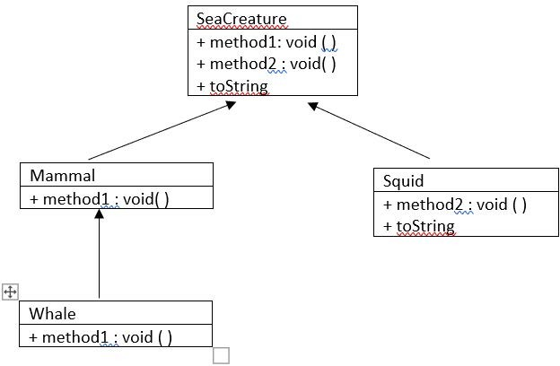

1. Identify **NINE** syntax errors in the following Java program segment and modify the program to remove the errors.

|  |  |
| --- | --- |
| 1  2  3  4  5  6  7  8  9  10  11  12  13  14  15  16  17  18  19  20  21  22  23  24  25  26  27  28  29  30  31  32  33  34  35  36  37  38  39 | **//Class Student**  public class Student { private String name; private String matricNum;  public Student(String n, String m) { name = n;  matricNum = m;  }  public void displayDetails() { System.out.println("Name: " + name); System.out.println("Matric #: " + matricNum);  }  }  **//Class UnderGradStudent**  public class UnderGradStudent extends Student { private String program;  public UnderGradStudent(String n, String m, String k);  super(n,m);  program = k;  }  }  **// class PostGradStudent**  public class PostGradStudent extends Student { private String supervisor;  public PostGradStudent(String n, String m, String s)  {  super(n,m);  s = supervisor;  }  public void displayDetails() { System.out.println("Name: "+name); System.out.println("Matric #: "+matricNum); System.out.println("Supervisor: "+supervisor);  }  } |

1. Please complete code based on the output given.

**class** Bird {

//a) the constructor class Bird and method Fly

}

**public class** BirdApp {

**public static void** main(String[] args) {

//b instantiate the Birds Object

myBird.fly(); myBird.fly(10000); myBird.fly("eagle", 10000);

}

}

Output :

The bird is flying.

The bird is flying 10000 feet high. The eagle is flying 10000 feet high.

a)

public class Bird {

private String name; private int height;

public void fly() {

System.out.println("The bird is Flying.");

}

public void fly (int h) {

this.height=h;

System.out.println("The bird is flying " +height+ " feet high.");

}

public void fly(String n, int h) { this.name=n; this.height=h;

System.out.println("The " +name+ " is flying " +height+ " feet high.");

}

}

b)

public static void main(String[]args) { Bird myBird = new Bird(); myBird.fly(); myBird.fly(10000); myBird.fly("eagle", 10000);

1. Why is following code showing compile error?

**public class** AnimalApp{

**public static void** main(String[] args){

Animal[] a = {**new** Animal("Animal"),**new** Dog("Dog"),**new** Cat("Cat"),

**new** Lion("Lion")};

**for**(**int** x=0 ; x<a.length; x++) { a[x].eat();}

}

}

**class** Animal{

**protected** String animal_type;

**public** Animal(String type) { animal_type=type;

}

**void** eat(){

System.***out***.println(animal_type + " eating...");}

}

**class** Dog **extends** Animal{

**void** eat(){System.***out***.println(animal_type + " eating bone...");}

}

**class** Cat **extends** Animal{

**void** eat(){System.***out***.println(animal_type + " eating fish...");}

}

**class** Lion **extends** Animal{

**void** eat(){System.***out***.println(animal_type + " eating meat...");}

}

a)

Because there is no constructor in the subclasses

b) Fix the error from the following code and display the output. Answer b):

public class Dog extends Animal{ public Dog(String type) {

super(type);

}

public class Lion extends Animal{ public Lion(String type) {

super(type);

public class Cat extends Animal{ } public Cat(String type) {

super(type);

}

Output

Animal eating... Dog eating bone Cat eating fish... Lion eating meat..

1. a) Based on the following code, can you find any problems? Explain your answer.

|  |  |
| --- | --- |
| 1  2  3  4  5  6  7  8  9  10  11  12  13  14  15  16  17  18  19  20  21  22  23  24  25  26  27  28  29  30  31  32  33  34 | **class** Loan {  **public double** getRateOfInterest() {  **return** 4.5;}  }  **class** Car **extends** Loan {  **public double** getRateOfInterest() {  **return** 3.6;}  **public** String toString() {  **return** "Car";}  }  **class** House **extends** Loan {  //c  }  **class** Land **extends** Loan {  **public double** getRateOfInterest() {  **return** 6.5;}  **public** String toString() {  **return** "Land";}  }  **public class** LoanApp {  **public static void** main(String args[]) {  Car[] loan= {**new** Car(), **new** House(), **new** Land()};  **for** (**int** i=0;i<loan.length;i++) { System.***out***.println("Interest Rate for " +loan[i] + " is " +loan[i].getRateOfInterest() + "%");  }  }  } |

a)

In Line, the instance object created Car [ ] loan supposedly be Loan [ ] loan. This is because the class Loan is the super class so that the sub classes can inherit methods from the super class.

1. What is the output for the code after you fix the problem in a. Explain why it happen. Answer b):

Interest Rate for Car is 3.6% Interest Rate for House is 4.5% Interest Rate for Land is 6.5%

1. Complete the class House so that the correct output can be generated.

Answer c):

class House extends Loan {

public double getRateOf Interest( ) {

return ;}

public String toString( ) { return "House";}

1. In your opinion, what is the purpose of toString Method in this code. Are we overload the method or override it? Share your idea.

Answer d):

The purpose of toString Method in this code is to return the value for particular class in String format.The method is override because the toString method was use multiple time in different subclass